Date: 2016.10.05

Request: Scan OFI function to allow scanning by Box ID and seqno checking.

Upon completed scanning per box, close box and print shipping mark

System Process:

1. OFI import – after import SO , system will auto define BOX ID and seqno according to the Picklist split line ( 3 lots per box/split line)
2. OFI Scan - OFI scanning will check scanning by BoxID and by reverse sequence in Picklist . i.e.

Example: sorting in Picking list:

Box iD Seqno Lot#

1. 1 A

1 2 B

1 3 C

Scanning will validate user must scan Lot# C, then follow Lot# B and last Lot# A. Box1 complete.

After completed Box1, system will print Shipping mark

User must complete the current SO before proceed to next SO.

SO = SO + SOline #

Development Specification:

1. **OFI Cartonization – when Import SO**

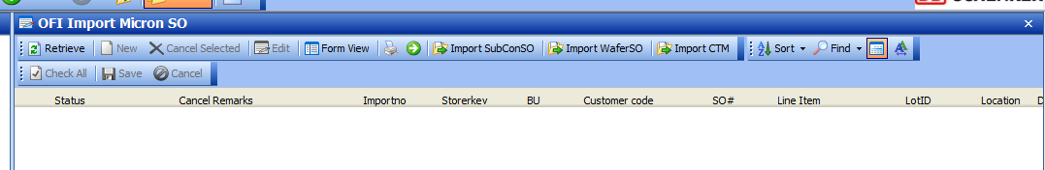

1. ~~Reference table OFIBU~~

~~CODELKUP.Listname = ‘OFIBU’~~

|  |  |  |  |  |  |
| --- | --- | --- | --- | --- | --- |
| **~~List Name~~** | **~~Code~~** | **~~Description~~** | **~~Short~~** | **~~Long~~** | **~~Remarks~~** |
| ~~OFIBU~~ | ~~CTM~~ | ~~CTM~~ | ~~3~~ | ~~r_report_ofi_picklist_ctm~~ | ~~Picking sort by materialno and location~~ |
| ~~OFIBU~~ | ~~REBAG~~ | ~~REBAG~~ | ~~3~~ | ~~r_report_ofi_picklist~~ | ~~Picking sort by location~~ |
| ~~OFIBU~~ | ~~SUBCON~~ | ~~SUBCON~~ | ~~3~~ | ~~r_report_ofi_picklist~~ | ~~Picking sort by location~~ |
| ~~OFIBU~~ | ~~WAFER~~ | ~~WAFER~~ | ~~3~~ | ~~r_report_ofi_picklist_byadddate~~ | ~~Picking sort by Adddate~~ |

## Cartonization Specification:

### New table: SCH_OFI_CARTONIZATION_CONFIG

|  |  |  |  |  |  |
| --- | --- | --- | --- | --- | --- |
| Storerkey | BU | GroupbyCol | OrderByCol | LotPerBox | DWPickListObj |
| MICRONSKH | CTM | SO, Soline, FGMaterialNo | SO, Soline,  FGMaterialNo, Location | 3 | r_report_ofi_picklist_boxid |
| MICRONSKH | REBAG | SO, Soline | SO, Soline, Location | 3 | r_report_ofi_picklist_boxid |
| MICRONSKH | SUBCON | SO, Soline | SO, Soline, Location | 3 | r_report_ofi_picklist_boxid |
| MICRONSKH | WAFER | SO, Soline | SO, Soline, AddDate | 3 | r_report_ofi_picklist_boxid |
| MICRONSKH | CTM | SO, Soline, FGMaterialNo | SO, Soline,  FGMaterialNo, Location | 3 | r_report_ofi_picklist_boxid |
| MICRONSKH | REBAG | SO, Soline | SO, Soline, Location | 3 | r_report_ofi_picklist_boxid |

### Cartonization Logic:

Create new SP: **SCH_OFI_Cartonization** ( @c_Importno varchar(10) , @c_errmsg varchar(255) OUTPUT )

* + 1. Source table : SCH_OFI_OUTBOUND_SO_LOT
    2. Data set sorting logic by BU
       - 1. Get information from Config. table: SCH_OFI_CARTONIZATION_CONFIG

GroupbyCol – order grouping for generate different pick list group. Each group will be packed separately as it’s own set of BoxID running number.

OrderbyCol – define the grouping sorting sequence. This is to define the BoxID and Seqno.

LotPerBox – to define the number of lot# per box.

Eg. For BU=SUBCON

SO#1 with 5 lot#, SO#2 with 6 Lot#

|  |  |  |
| --- | --- | --- |
| SO | BoxId | Seqno |
| SO1 | 1 | 1 |
| SO1 | 1 | 2 |
| SO1 | 1 | 3 |
| SO1 | 2 | 1 |
| SO1 | 2 | 2 |
| SO2 | 1 | 1 |
| SO2 | 1 | 2 |
| SO2 | 1 | 3 |
| SO2 | 2 | 1 |
| SO2 | 2 | 2 |
| SO2 | 2 | 3 |

* + 1. ~~Get no. of lot# (n) per box setup in Codelkup (Listname = ‘OFIBU’)~~

~~Isnull (Select short from codelkup where listname = “OFIBU’ and code = {BU},~~

~~** if it’s not setup, default to 3~~

~~Every BoxID will have total (n) Lot#~~

* + 1. Determine and update the BoxID , Seqno and OuterLP.

Update –table SCH_OFI_OUTBOUND_SO_LOT

outerLP = (1 boxID = 1 OuterLP ), i.e Outbound box LP or TULP ,

OuterLP format: prefix with MC + 6 digit running number from ncounter keyname='OFIOUTLP'

* 1. New SP to invoke in HUB – Import SO Screen, for import function, after success imported SO.
     1. Import SubconSO
     2. Import WaferSO
     3. Import CTM

1. **Pick List**

Create new Pick list to sort by Box ID follow Seqno

Setup auto picklist printing configuration in Codelkup - Listname = ‘OFIBU’

Update long = {new_picklist_dw} for auto-email picking list.

1. **OFI Scanning - Packing**
   1. OFI SCAN logic and requirement:
      1. Scanning will validate user must scan Lot# C, Then follow Lot# B and last Lot# A. Box1 complete.
      2. After completed Box1, system will print Shipping mark
      3. User must complete the current SO before proceed to next SO.
   2. Screen: OFI Scaning – Packing
      * 1. Create New object OFI Scannning packing
        2. Scaning step:
           1. Scan1

If 1st scan Lot # , set data in [Display]- retrieve SO#, Box ID ( display on the scanning screen) , scanned = total #lot scanned ,Total = total # of lot

else validate the SO# is same as previous SO#, if different prompt Error message screen. “ Please complete the current SO.” Reject scan1

IF same SO, validate if same Box ID and validate scan lot seqno

If invalid, prompt error message screen. Reject scan.

If valid continue scanning “Scan 2”

**[DISPLAY]:**

SO# SO Line:

Box ID:

OutStd:

67909912

4100

1

5

Scan 2… Scan 6 continue . no changes

If Last Scan # , update SO status to ‘6’ ( Lot scan completed, the status was ‘9’ before new scan logic) for Lot scan complete..

If lot # is last Lot# in the BoxID,

Print shipping mark

Box ID close update – Table SCH_OFI_Outbound_lot.**BoxIDClosedDate**

Display message on header, Box ID nn close completed message information

If lot # is last Lot# in the SO,

Update **status = ‘9’ and** **SOScanCompletedDate** ( status for SO Pack completed) for entire SO.

Prompt SO scan completed message information.

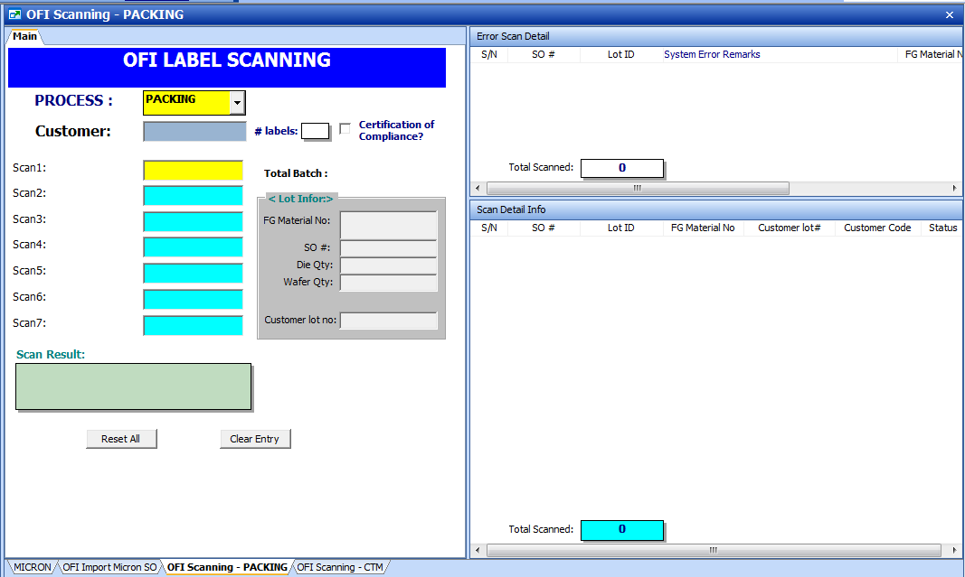

DISPLAY

1. Generate Shipping mark

Use Zebra printer. model TBC

Label Size: 110 by 450MM

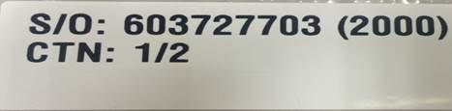

**OFISTATUS changes**

Current OFISTATUS

select * from CODELKUP where LISTNAME = 'OFISTATUS'

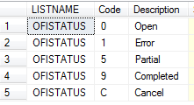

New:

|  |  |  |
| --- | --- | --- |
| **List Name** | **Code** | **Description** |
| OFISTATUS | 0 | Open |
| OFISTATUS | 1 | Error |
| OFISTATUS | 5 | Partial |
| OFISTATUS | 6 | Lot Completed |
| OFISTATUS | 9 | Box Completed |
| OFISTATUS | C | Cancel |